4th June 2020

Dear Parent/carer,

In this very difficult and complex time could I please share with you the context of Villa Real School and a leaflet enclosed, regarding returning to school. Currently as you know the R rate for the North East is 0.8 and within that County Durham has the highest incident of infections and deaths. Durham County Council updated their advice to schools following this information and the recommendations of the SAGE group.

At Villa Real school we have been open to a very small number of pupils whose parents are keyworkers or children who are Looked After or whom medics risk assessed as requiring some limited hours within school. Throughout this period we have been responding to the latest Public Health Advice and government direction alongside liaising weekly with the Chief Medical Officer regarding PPE, social distancing measures and changes to our environment.
The school has a cleaner during the day who is constantly emptying bins and cleaning areas of continuous use. Areas are marked out for social distancing. Chairs, furniture, soft furnishing, toys and certain displays have been removed. Classes are taught in bubbles. Staff are maintaining handwashing and wearing clean clothes daily or wearing scrubs. Those at higher risk are wearing masks and gloves all of the time and for all intimate care staff are wearing PPE.

The school had also ordered social distancing stickers, extra thermometers, heat seeking machines, screens, handwashing stations and a range of additional resources. Despite delivery dates of last week much has still not arrived due to COVID disruption in delivery services. School is also still waiting for contact from the Infection control nurse regarding the visors the school has to support with pupils who spit or have difficulties with other bodily fluids. DCC has not yet developed a Transport Protocol for the Transport team of taxi drivers and Villa Real have written a basic one for all taxis until DCC guidance is ready. The school has staggered pupils’ entrance into the school.

Since June 1st the school has opened to some children in Reception, year 1 and year 6 (despite DCC guidance) where we felt safe to do. We have however worked with families and delayed 10 children in these year groups starting until 8th – 15th June whilst we make further environmental changes for the increased numbers. Since 1st June transport has been a particular issue with many taxis not arriving at the allocated time and causing bottlenecks. The school is also examining different signing in regarding routes into school as the numbers increase. Most staff who are Clinically Vulnerable have returned to school for some time this week but many staff in this category are still unavailable due to their own children’s school not opening full time for them. The staff are keen to return to work and support your children. We also have staff still shielding as Highly Vulnerable or acting as carers themselves. We are continuously risk assessing and adapting to ensure all children and all staff are as safe as they can be. We are hopeful we will be able to offer all Reception, year 1 and year 6 pupils whose parents wish them to return to school a place by 15th June.

The government have stated that 25% of year 10 and year 12 who are working towards exams in the next year should be offered some face to face time with teachers from 15th June. From the 15th June parents of pupils in these 2 year groups, who are completing exams in the next year, will be contacted to be offered some hours in school. We are also constantly reviewing with families any pupils who have begun to medically struggle at home and who we may need to be offered some provision after risk assessing with multi agency professionals on a case by case basis.

I hope this clarifies our position and you understand we all want to see you and your children as soon as possible but we have to only do so when it safe to do so, in order to ensure that your child remains safe, happy and healthy.

Yours Sincerely,

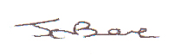

Mrs JE Bowe
Headteacher

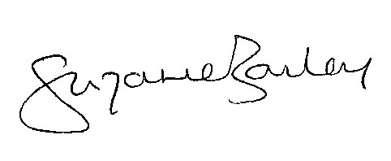

Mrs S Bailey
Chair of Governors

