Dear Parent/carer,

Thank you for your responses to our recent Homework Questionnaire. The results were extremely positive.

Many parents requested more project/family activities to complete at home, so that siblings, grandparents and friends could join in.

Please find attached our Activity Passport which has been introduced by the Department of Education, but we had modified it for our children. These are optional activities that can be completed alongside the Literacy, Numeracy and Reading homework that is sent home weekly.

Class teachers will collect these each half term. We would love to see your children taking part in these activities and would welcome any photos sent to our main email, villareal@durhamlearning.net

Yours sincerely

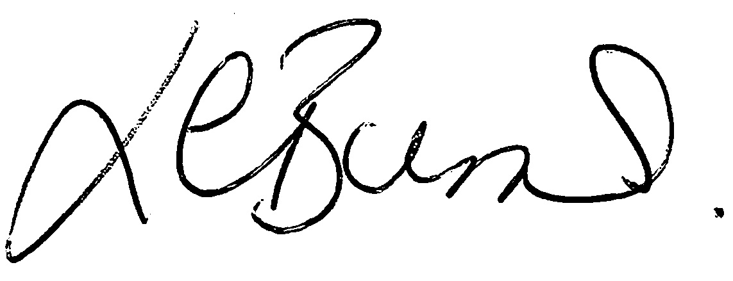

Louise Burns

