Dear Parent/carer,

Please find attached the review of the Autumn terms REAL targets and the new ones for this term. These targets have been written by class managers and focus on our REAL curriculum areas. They may differ slightly to the EHCP objectives, as many of the plans were written over a year ago due to the time delay of the final versions.

Please could you complete the slip below and return it to school.
Yours sincerely

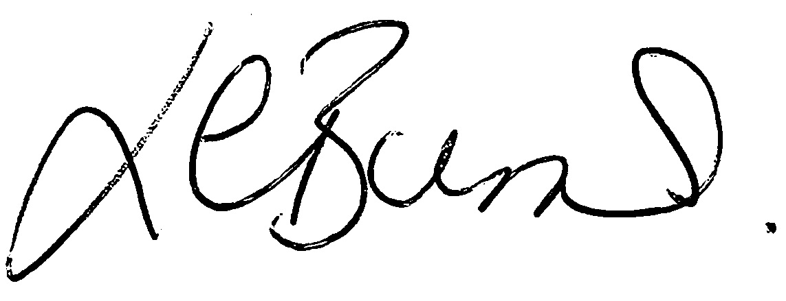

Louise Burns
Deputy Head
SENCo

Name of pupil/student –

I acknowledge receipt of the REAL targets January 2020

Signed ______________________________

I would like to discuss these further with SENCo/Head teacher – YES/NO

